**Revolutionizing Digital Financial Services in BAngladesh**

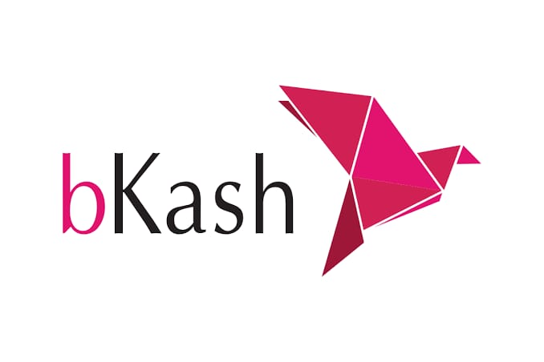

**Name: Sania FardusheJuthi**

**ID NO:20**

**Batch: 21**

Contents

1 Executive Summary: 2

2 products and Services 3

2.1 Hyperlink: 3

2.2 Smart Art: 4

3 BUSINESS PLAN: 4

3.1 Flow chart: 4

4 Sales and Cost Statistics: 6

# Executive Summary:

‘bKash’ is a word that resonates with development, people’s prosperity, and social growth. Since its inception in 2011, bKash has become an integral part of the lives of millions today. Through fast, easy, and secure digital transactions, it has become a member of every household in Bangladesh, and the word ‘bKash’ has become a verb. People now say ‘bKash koro (me)’ instead of ‘send me money’. Catering to people’s daily transactional needs, it is empowering them to fulfill their dreams as well as taking the country forward.

Financial inclusion is in the DNA of bKash. Driving technological innovation and keeping compliance in all its dealings, the company has been bringing a wide range of services to empower customers and bring freedom in their financial transactions. Over the years, bKash has built a robust network of nearly 330,000 agents and 550,000 merchants across the country. bKash also integrated with banks, financial institutions and service providers to strengthen the cashless digital financial ecosystem of the country. As a result, bKash is now a trusted platform with a large customer base of more than 70 million.

bKash, a joint venture of BRAC Bank, US based Money in Motion LLC, International Finance Corporation of the World Bank Group, Bill and Melinda Gates Foundation, Ant Group, and SoftBank Vision Fund, operates under the regulation of BangladeshBank.

# products and Services

1. **Mobile Wallet**: Users can open a bKash account to store money digitally, allowing for easy access and management of funds.
2. **Money Transfer**: bKash enables users to send and receive money instantly to and from other bKash accounts, as well as to bank accounts.
3. **Bill Payments**: Customers can pay utility bills, such as electricity, water, and internet, directly through the bKash app.
4. **Merchant Payments**: bKash allows users to make payments to various merchants, both online and offline, enhancing cashless transactions.
5. **Cash Withdrawal**: Users can withdraw cash from their bKash accounts through a network of agents and ATMs.
6. **Deposit Services**: Customers can deposit cash into their bKash accounts via agents or partner banks.
7. **Savings and Investment**: bKash offers options for savings and investments, including fixed deposits and other financial products.
8. **International Remittance**: bKash facilitates the receipt of international remittances, allowing users to receive money from abroad.
9. **Microloans**: In collaboration with financial institutions, bKash offers microcredit services to eligible users.
10. **Promotions and Offers**: bKash often runs promotions and cashback offers to incentivize users and merchants.

## Hyperlink:

Offers

Some offers that are available now

## Smart Art:

# BUSINESS PLAN:

## Flow chart:

**Perform transaction**

**Load money into Baksh Account**

**Security andQuick Process**

# Sales and Cost Statistics:

|  |  |  |
| --- | --- | --- |
| **Month** | **Transaction Volume (BDT)** | **New Customers** |
| January | 500,000,000 | 200,000 |
| February | 550,000,000 | 220,000 |
| March | 600,000,000 | 250,000 |